**Year Airline Perfomance Report - 2019**

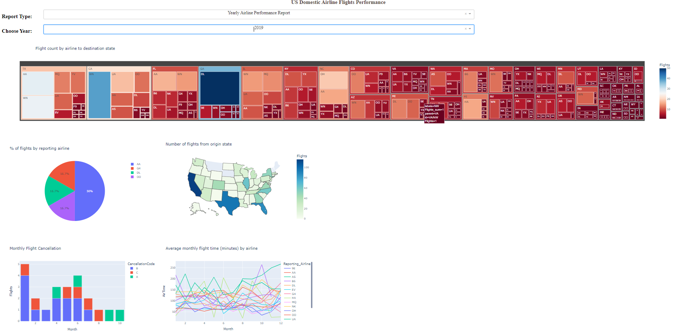

**Year Airline Perfomance Report 2015**

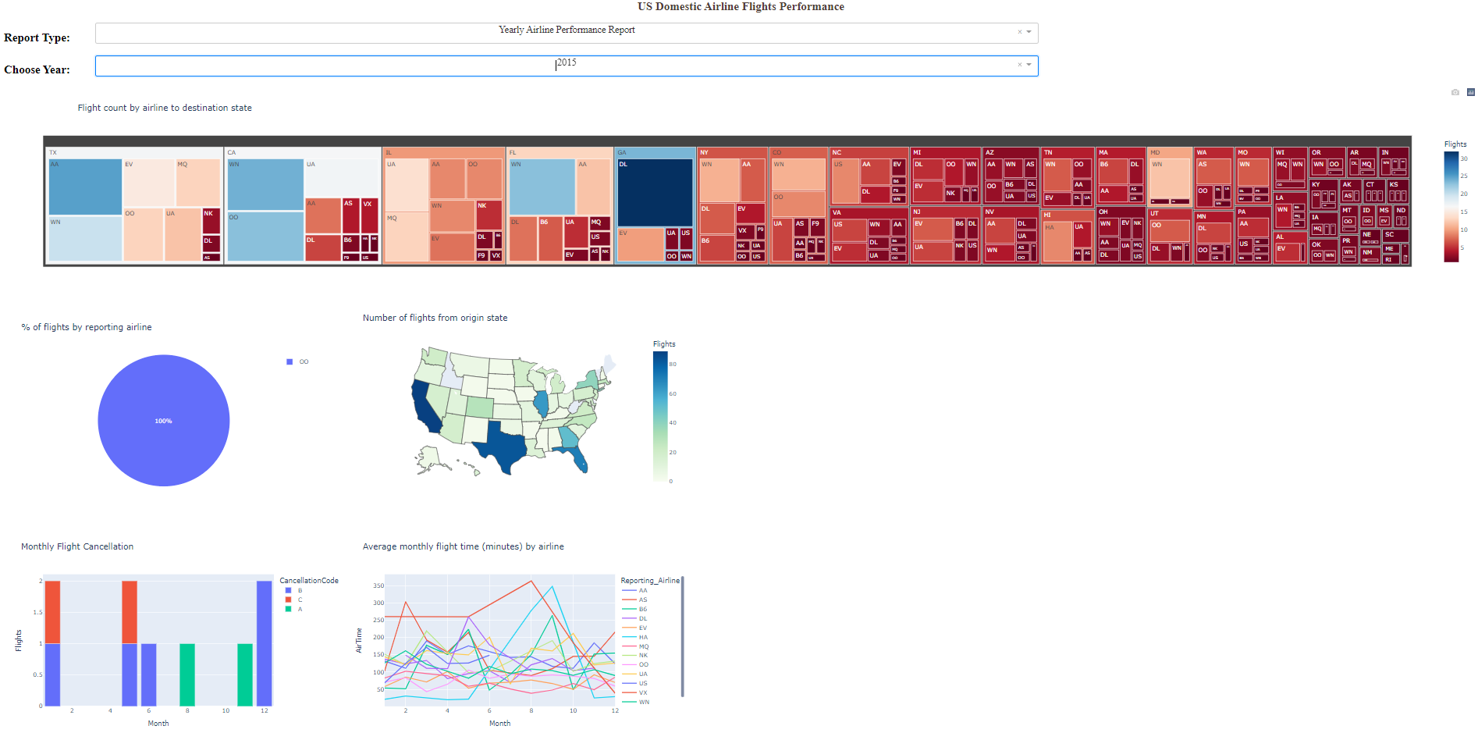

**Year Airline Delay Report - 2019**

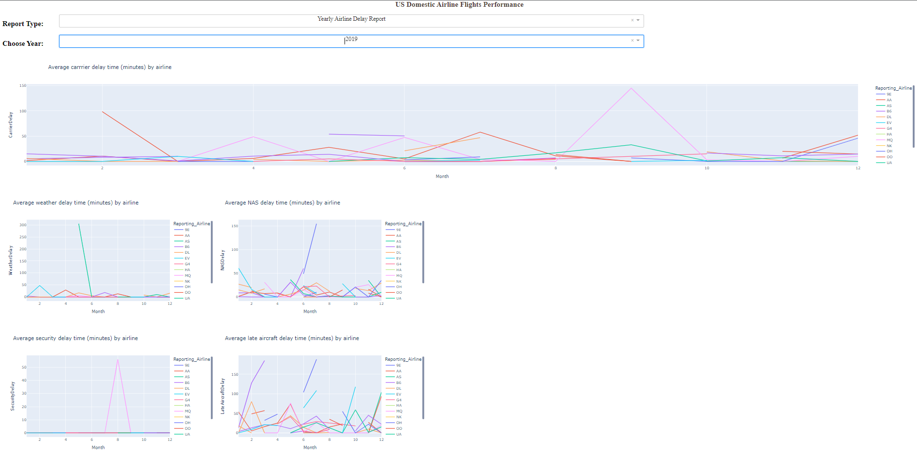

**Year Airline Delay Report - 2008**

